Action 29a & 29b, by Alison Starr

Action 29a
Inspired by Woman Throwing Handkerchief in Air, Picking It Up, from the book Animal Locomotion ca. 1887 (Eadweard Muybridge)

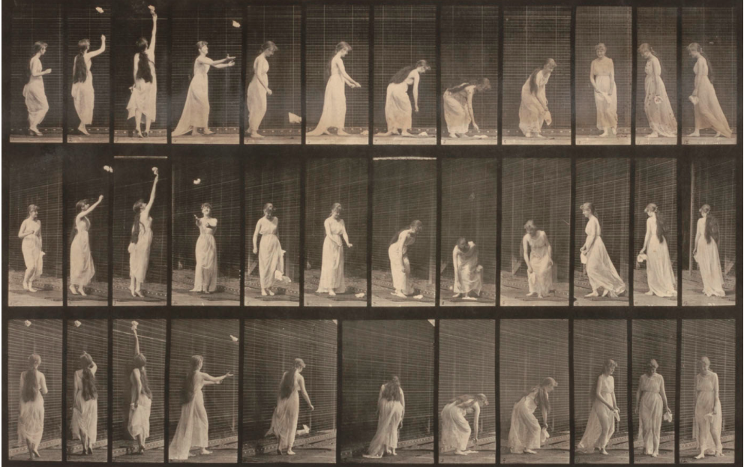

A young woman in clothing contemporary to her day and time – can be a dress, jeans and shirt (referencing Bruce Nauman’s actions – white T-shirt and jeans and bare feet) enters a room (possibly a black box) behaving as thought she is searching for something. In the center of the room on the floor is a white handkerchief. She takes about 2 minutes looking around, looking all over the room but the floor. She steps on the handkerchief as though she hadn’t seen it a few times. Finally she walks to the center of the room and sits legs crossed on the handkerchief. While sitting on the handkerchief she makes several attempts to sit in different positions (attempting the stereotype of a more “lady-like-knees-together-legs-swung-out beside-you”) but none of them suit her. After 2-3 minutes of attempt she stands up, looks down and sees the handkerchief. Bending down to pick it up she stays bent over for at least 30 seconds while holding and fondling the handkerchief. She plops down on the floor, handkerchief in hand, sitting legs spread eagle. She takes the handkerchief and swishes it all around her, brushing her legs and arms, face, back and front for about 3 minutes or so. The young woman gets up (almost like a child excited to do something) with handkerchief in hand to make the “last action” which involves a five minute throwing and chase of the handkerchief. She begins throwing the handkerchief wildly and forcefully sometimes chasing and catching, other times allowing it to fall and she possessively grabs it up only to throw and chase again. At times she throws the handkerchief between her legs, others around her waist; she keeps throwing forcefully and chasing and catching with intention and strength. End action is the young woman looking around her as if realizing others are watching then walking to the center of the room and daintily raising her arm with the handkerchief, allowing it to float and drop to the floor. Not looking down at the handkerchief or around anywhere else but looking forward she calmly turns toward the door and simply walks out.
END ACTION.
(written for Lita Bush)

29b (Revision when adding Zuma):

Young man (Zuma) wearing a dark suit and slick shoes escorts young woman (Lita), wearing sheer gown into an empty room (either middle or front room of BEEFHAUS). He escorts her to the center and stands beside her. Both stand still for a count of 10 – 15 seconds. Then the young woman begins by slowly raising her arm with the handkerchief – as soon as she does the young man turns to face the end of one wall walks over to it and begins walking the length of the wall (on the floor) feet and facing the wall as if measuring the wall or measuring time. When he gets to a corner he slowly turns facing away from the wall yet turning and pauses a minute when facing out…(as if checking on the young woman) but then resumes his “wall walking” until he meets another corner only to do the same. He continues doing this as long as the young woman is acting out her performance. Meanwhile the young woman begins dropping her handkerchief in a variety of ways…beginning a bit simple and a bit passive. She mainly stays in the center of the room for some time. Viewers may begin to interact with her by trying to pick up the handkerchief or catch it. If they do and do not give the handkerchief back to the young woman she will walk over to the young man gently get him and bring him over to the “offender” and they will both stand on either side of the offender until the handkerchief is returned to her. Once it is the young woman will resume in the center of the room raise her arm which signals the young man to return to his “wall walking”. After some time the woman will get a little more active by throwing and not merely dropping the handkerchief. She will throw it forcefully up and forcefully down and forcefully out. She will move away from the center. She will try to catch the handkerchief this time. Sometimes doing so and others not. While this is happening the young man will jump up the wall ever so often as if trying to take something off the wall. When the young woman tires (she will push herself physically though) she will finally raise her arm and slowly drop the handkerchief to the floor and normally and casually walk over to the young man. Stand behind him for a second or two. Tap him on the shoulder and escort HIM out.
END ACTION

NOTE: This performance may take 10 or up to 15minutes.

